How to control gates remotely

Polytechnic University of Bucharest

Vitoga George Patrick

To achieve my purpose, I suggested the following circuit:

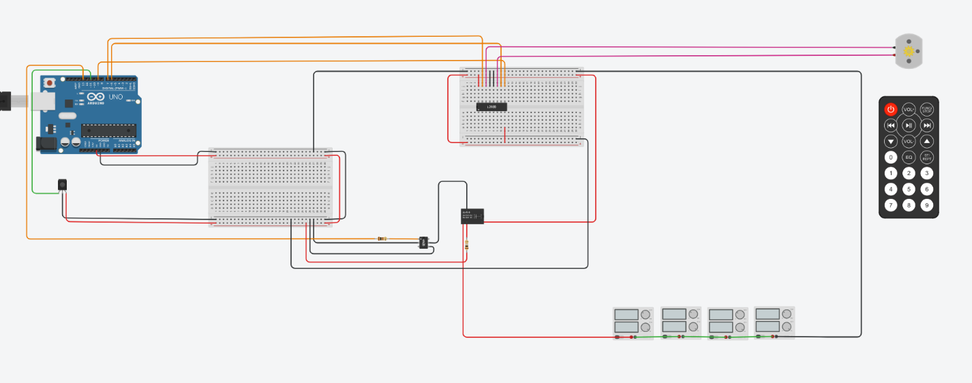

▶[*https://www.tinkercad.com/things/c3cK2TDj7u7*](https://www.tinkercad.com/things/c3cK2TDj7u7)

Components:

* Arduino Uno R3 ( 5 $ <https://ardushop.ro/ro/home/29-placa-de-dezvoltare-uno-r3.html>)
* IR sensor and remote (10 $ <https://www.sparkfun.com/products/14677>)
* Optocoupler 4N35 (0.5 $ <https://ro.farnell.com/webapp/wcs/stores/servlet/search?st=4n35>)
* Resistor 100 Ω + 1 Ω (2 $ <https://www.justradios.com/resorderform.html>)
* Relay LU-5-R (2 $ <https://ciiva.com/part/lu-5-r-10874344>)
* H-Bridge L293D (1 $ <https://bit.ly/364zq0f>)
* DC motor (40 $ <https://www.directindustry.com/prod/groschopp-ag-drives-more/product-7205-2172167.html>)

TOTAL : ~ 61 $ vs Internet Kit Price ~ 610 $ (https://bit.ly/3dQEnN3)

10 x t I m e s s m a r t e r ✅

The circuit is composed from 4 main layers :

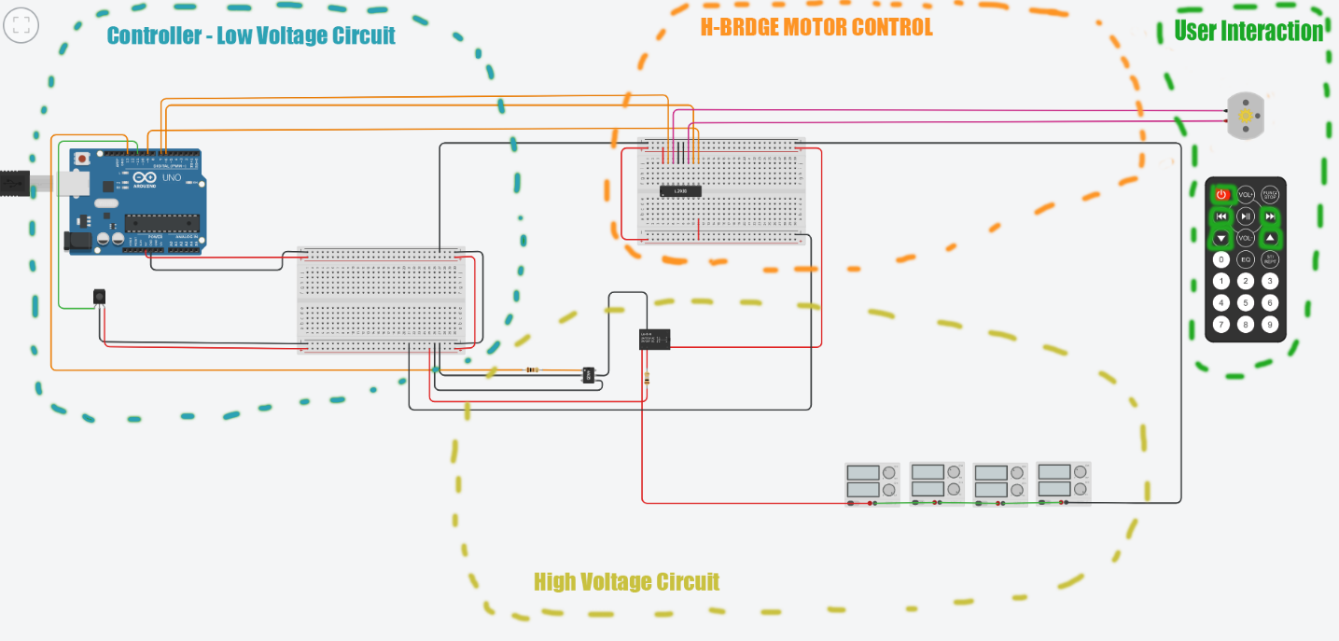

1. User interaction interface 🎮

2. H-BRIGE motor control 🎛

**3. Low to High voltage circuit transition ⚡**

4. Microcontroller logic Brain on Apple iOS 13.3

**User interaction interface** 🎮

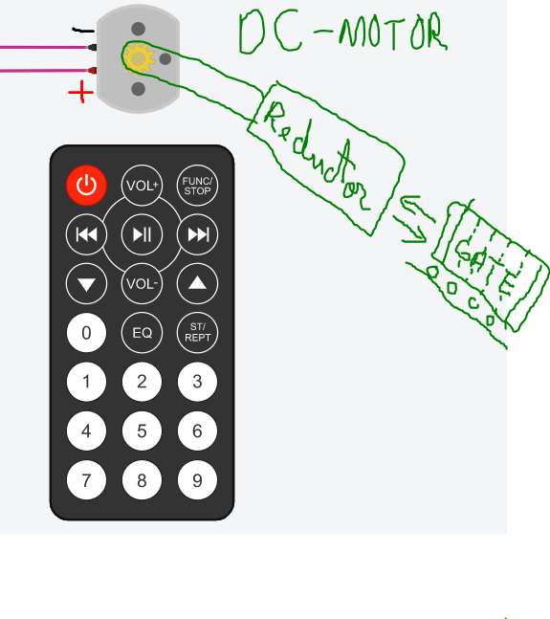

- Easy to integrate, a simple IR remote command the motor

- Need a proper reducing gear accordingly to the difficulty of the gate

- Need a rail to roll the gate open and close

The user can power/ unpower motor, choose direction for the rotation and also change the RPM value (my solution for anybody that could not find the perfect reduction gear, so they can adjust rotation speed ) .

**H - B R I D G E motor control** 🎛

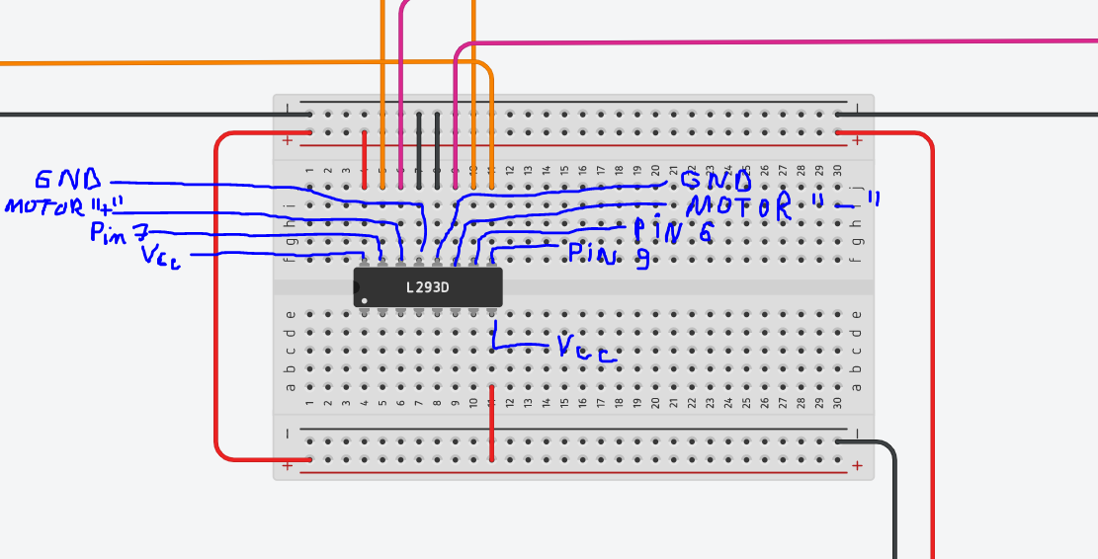

The most complicated part of the project was to use the

L293D motor driver . After many tries, I finally found the

secret of this alien component into this ancient papyrus :

<https://www.alldatasheet.com/datasheet-pdf/pdf/27189/TI/L293D.html>

**We need a way to feed this muscles . . . .**

**stand aside !**

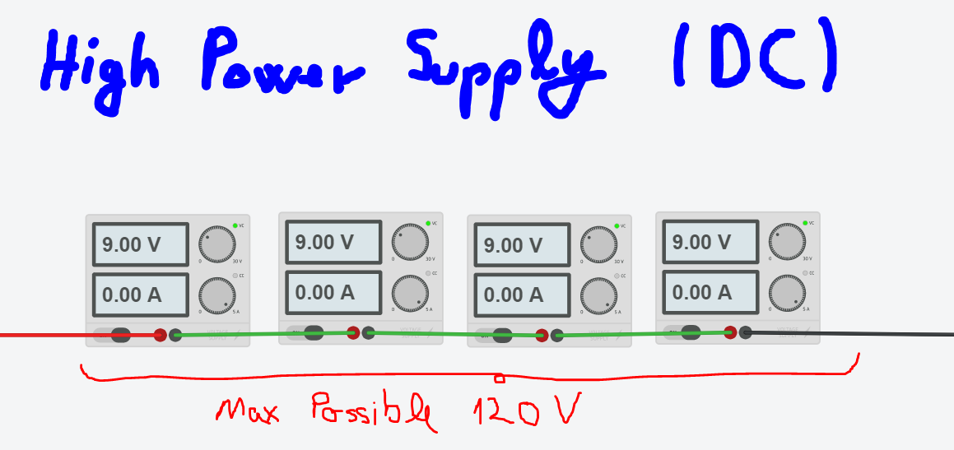

TinkerCad was very poor in terms of high power supply,

so the little engineer inside of me had to find a solution, so I

connected multiple power sources in series, being able to

request even 120 V . Face with Open Mouth on Apple iOS 13.3 ?!

**⚡**The separation of **High** & **Low** voltage circuit**⚡**

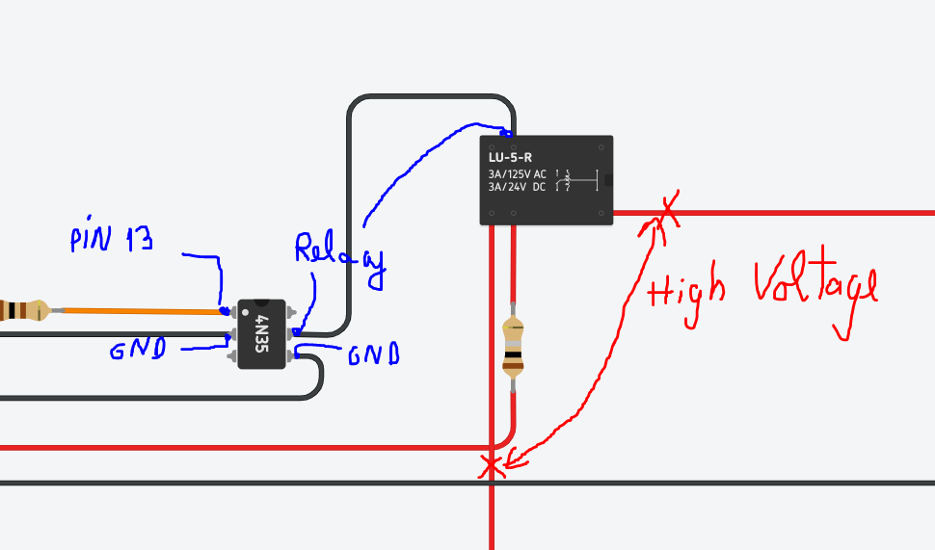

microcontroller + high voltage = 💗

4 N 3 5 + L U – 5 – R = 💔

T**o accomplish high voltage controlled with arduino, I got 5 letters :**

R E L A Y

T**o accomplish more decoupling and pain, I got another 11 letters :**

O P T O C O U P L E R + R E L A Y

  **, IR *control* *!!***

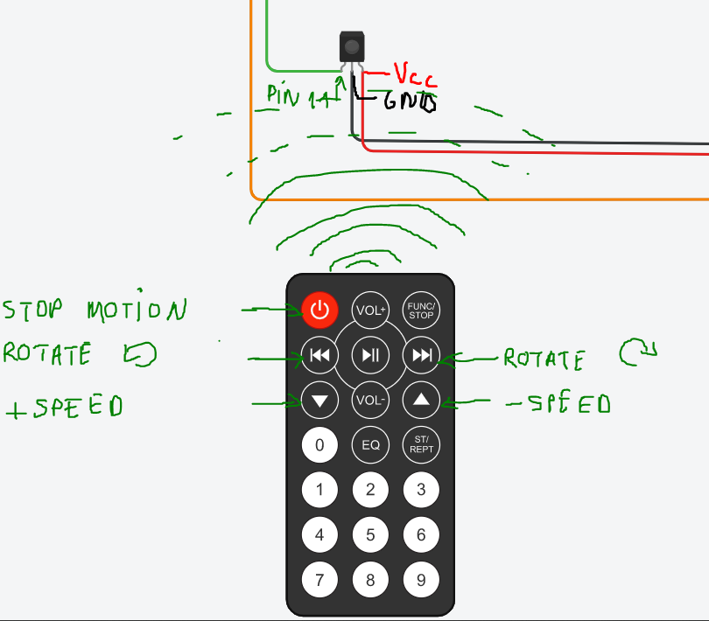

* IR sensor and remote connected on arduino (pin 11)
* #include < IRremote.h >

**A D V I C E :**

Never listen data from sensor on a pin which timer is already user to create pwm !

Microcontroller  ,

ARDUINO UNO R3

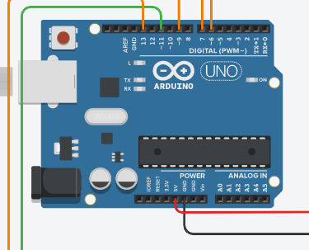

* Easy to setup
* Rich in terms of pins
* Smart enough
* FRAGILE to high voltage

CODING SESSION 👨‍💻 :

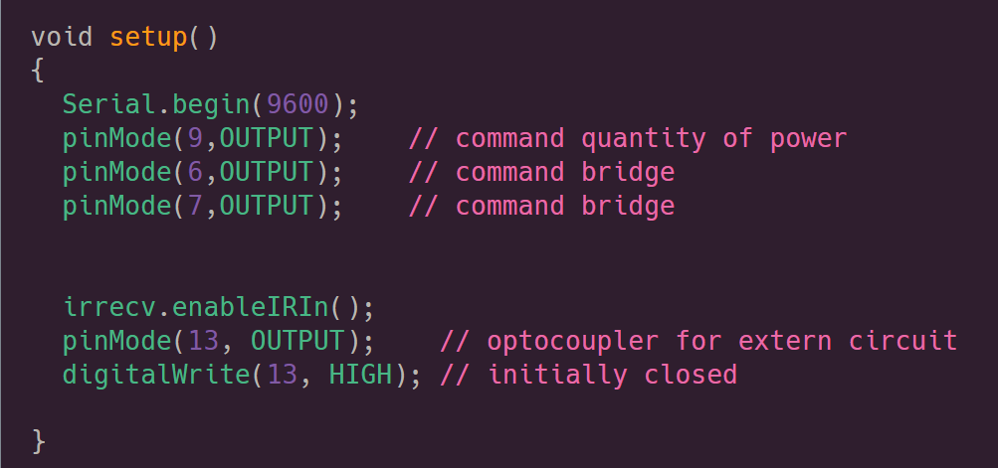

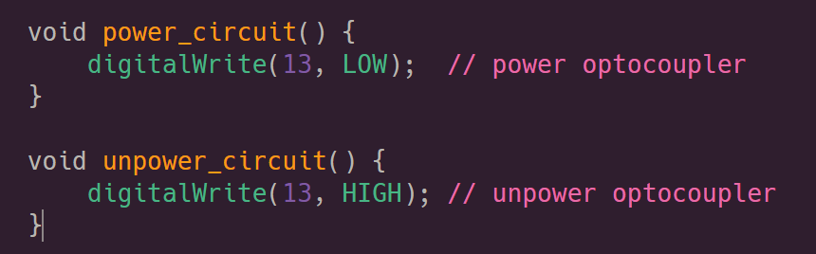

to decouple the circuit

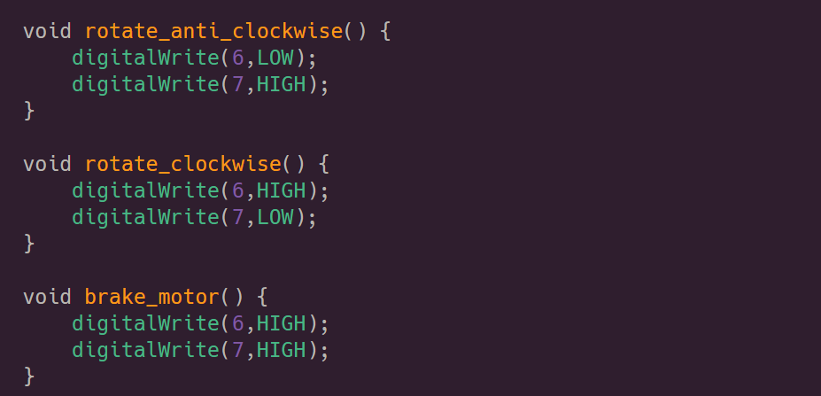

how does the motor act

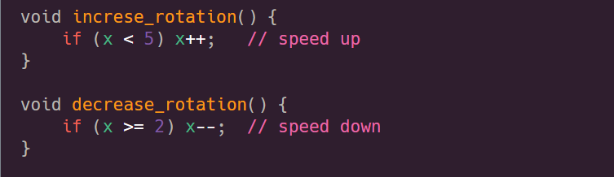

user is able to change RPM

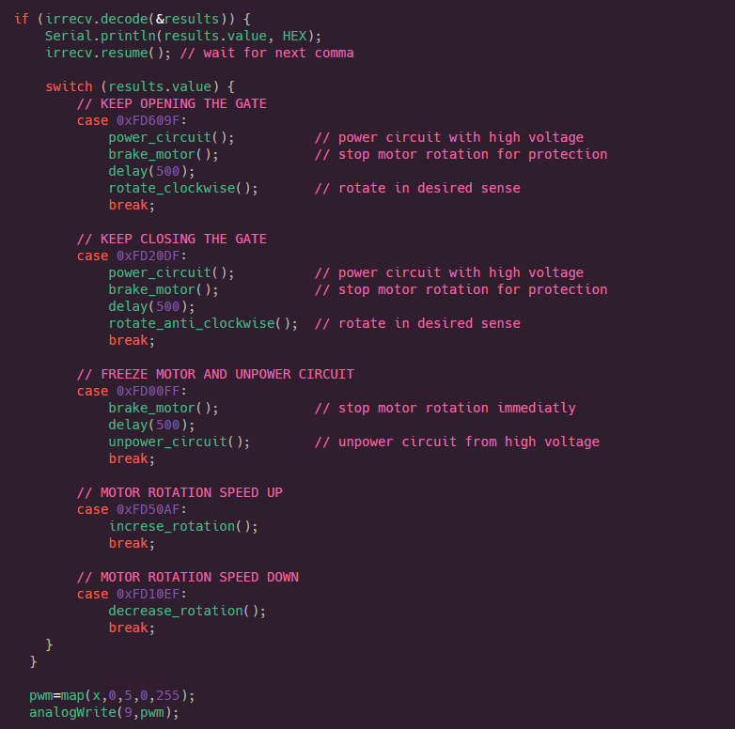

Here, I adopted a safety measure

Each time you change the behavior of the gates, first, the motor will brake and only after the motion is stopped, it will execute the next command, to prevent damage from the aggressive changes .